Experience Rating:
It uses 2 ways to display the data:
- Loss Summary
- Zspire Import
- The Experience Rating takes the years from zspire import when completed.
- The first and secnd grid take values from loss summary screen.
- The third grid takes values from the Zspire import data
- Then calculates MSL, below MSL
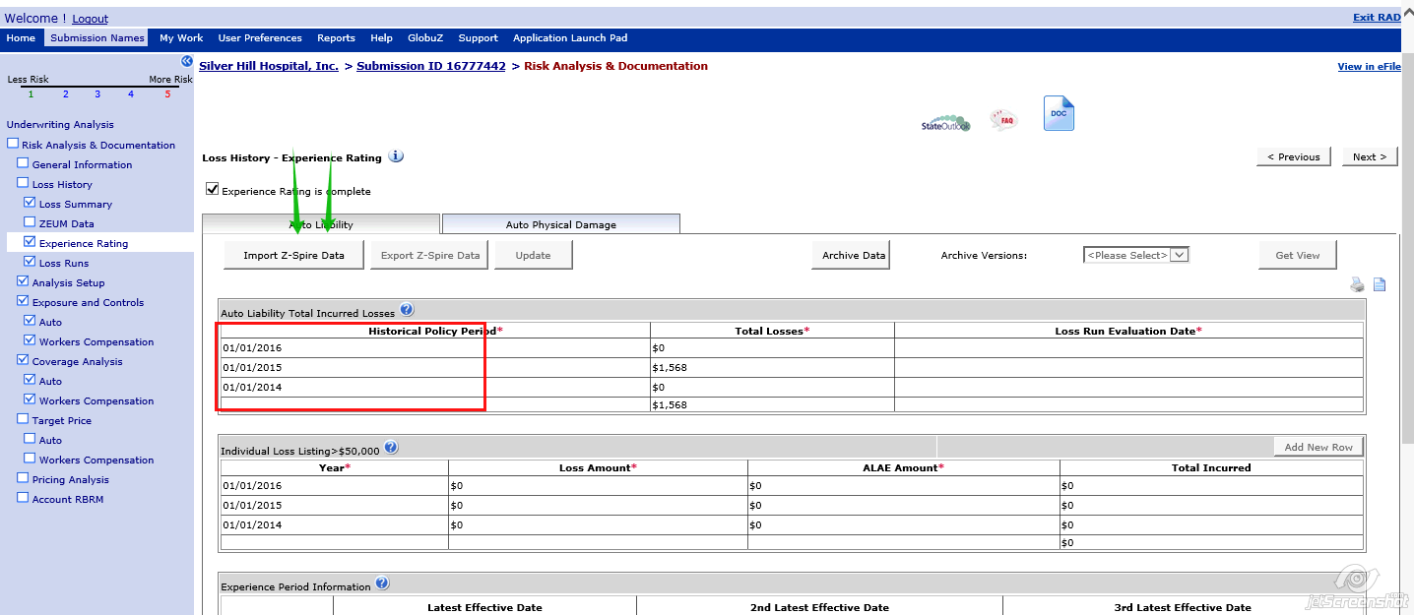
- The total losses data comes from loss summary screen.
- Loss Run Evaluation Date comes from the Evaluation date in the Loss Summary screen
- The first three valuation date are displayed on the experience Rating screen.
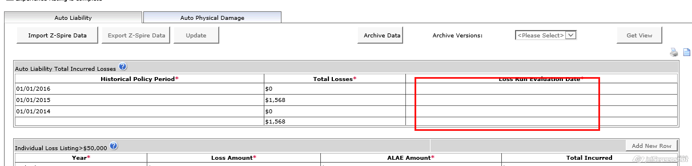
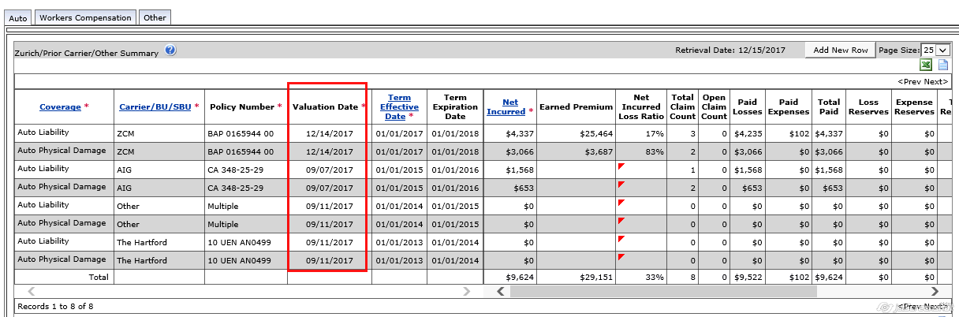

- How the data is coming:
  - In general Information screen it subtracts the date by 3 yrs
  - 2019 – 3 years = 2016 by which the data is displayed on the Historical Policy Period starting from 2016,2015,2014 for the 3 years in Row.
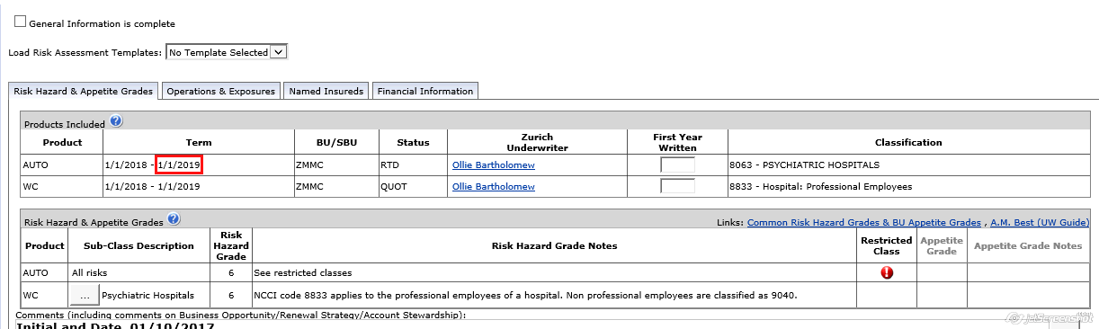

When issue arises:
- When the method checks for 2016(historical policy period)this data comes from the effective date in loss summary screen.
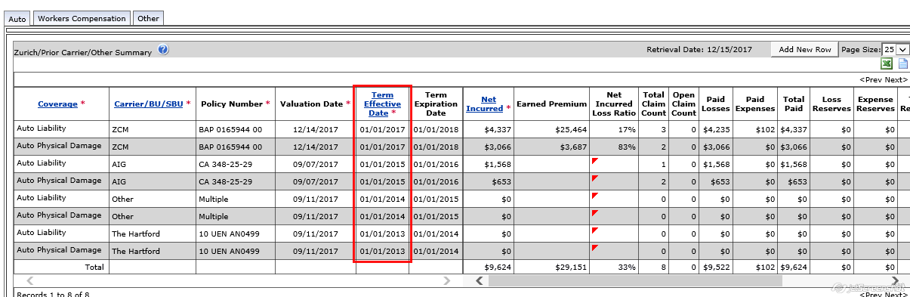
- It searches for 2016 but since it is missing it comes out of the method and breaks.
- Due to this the date in the loss run evaluation date is missing not present.
- This causes the export button to be disabled bcz loss run evaluation date is manadatory field and is missing due to missing year policy
- 